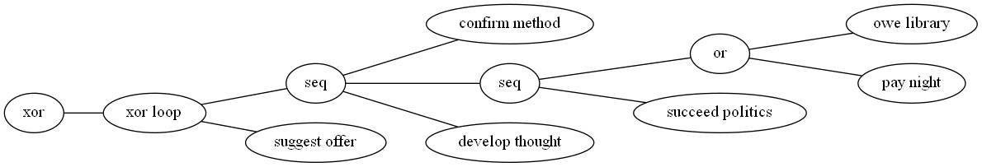

Ein Bild, das Reihe, Diagramm, Screenshot, Schrift enthält.

Ein Bild, das Diagramm, weiß, Entwurf, Reihe enthält.

Based on the process tree provided, a possible process description is as follows:

Process Description:

The process starts with the input event "X". From here, the process splits into two paths:

Path 1: 'confirm method'

\* The process flows to the node labeled 'owe library', where it performs the action 'pay night'.

\* Then, it flows to the node labeled 'succeed politics', where it performs the action 'develop thought'.

Path 2: 'suggest offer'

\* The process flows directly to the node labeled 'suggest offer'.

In both paths, the process ends at the final node, which is labeled 'X'.

Therefore, the overall process description can be represented as follows:

X -> (('confirm method', 'owe library', 'pay night'), ('develop thought', 'succeed politics')) -> 'suggest offer' -> X

This process model describes a sequential process with two parallel branches, where the outcome of one branch influences the next step in the main process. The process starts with the input event "X" and then splits into two paths based on the outcome of the "confirm method" node. In one path, the process pays night at the "owe library" node, while in the other path, it develops thought at the "succeed politics" node. Finally, both paths merge back into the main process and end at the final node labeled "X".